1A2 | English File 4th Edition A1. Student's Book and Workbook with Key Pack ISBN 9780194057950 | 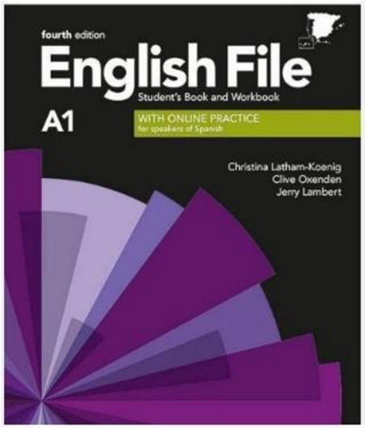
2A2 | English File A1/A2 Fourth edition. Christina Latham-Koenig and Clive Oxenden, Jerry Lambert and Paul Seligson. (Student’s Book and Workbook with ONLINE PRACTICE) Oxford.  ISBN: 978-0-19-403142-4 | 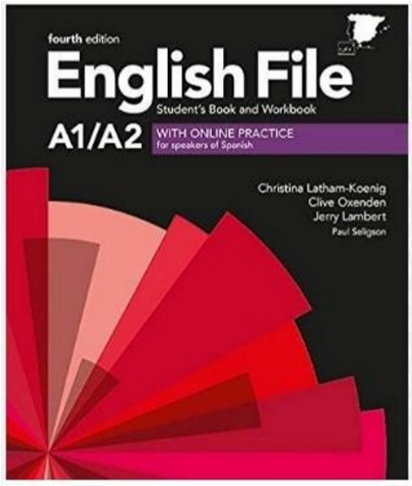
Intensivo 1 A2/2A 2 | English File A1/A2 Fourth edition. Christina Latham-Koenig and Clive Oxenden, Jerry Lambert and Paul Seligson. (Student’s Book and Workbook with ONLINE PRACTICE) Oxford.  ISBN: 978-0-19-403142-4
Sdffs
1B1 | English File A2/B1 Fourth edition. Christina Latham-  Koenig, Clive Oxenden, Jerry Lambert and Paul Seligson. (Student’s Book & Workbook with ONLINE PRACTICE) Oxford.  ISBN 978-0-19-403635-1 | 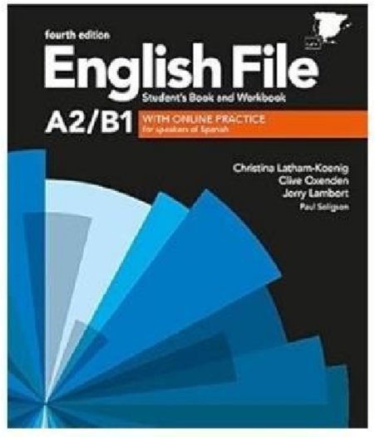
2B1 | Student’s Book & Workbook with key. English File 4th edition. Ed. Oxford.  ISNB: 9780194035651 | 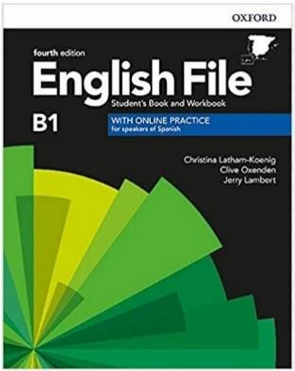
Intensivo 1B1/2B1 | MacMillan English Hub B1. Student's book and workbook. ISBN 9781380058546 | 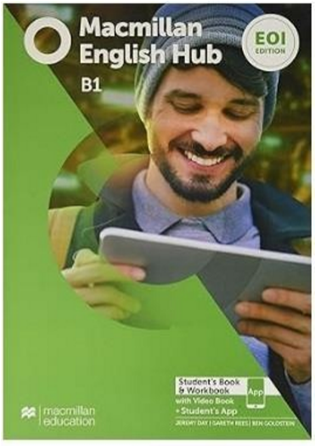
1B2 | Student’s Book & Workbook with key. English File B2.1 4 th edition. Ed. Oxford. ISBN: 9780194038768 | 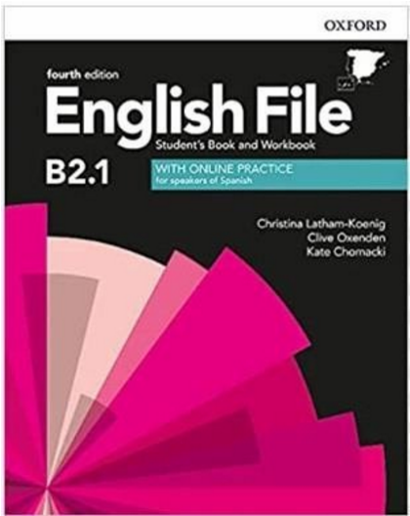
2B2 | MACMILLAN St's & Wb  English Hub B2 EOI Edition  ISBN 978-1-380-05866-9 | 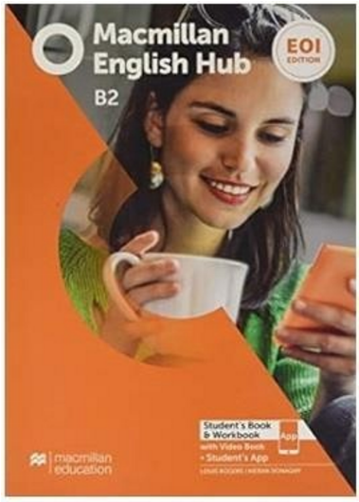
1C1 | Student’s Book & Workbook with key. Macmillan English Hub C1. Ed. Macmillan.  ISBN: 9781380058867 | 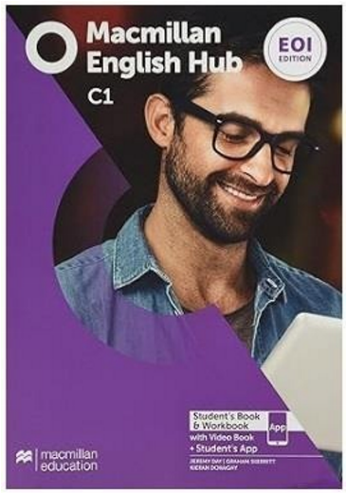
2 C 1 | READY FOR C1 ADVANCED Student´s book with key:  libro del alumno impreso y digital con respuestas  ISBN 9781380052438  READY FOR C1 ADVANCED Workbook with key: libro del alumno impreso y digital con respuestas  ISBN 9781380052469 | 