Title
Author¹
mail@author1.com, mail@author2.com
Centre of reference¹, Centre of reference²
Educational level: choose the one that applies: Pre-Primary Education, Primary Education, Secondary Compulsory Education, Post-Compulsory Education, Vocational and Education Training, Adult Education, EOI or Inter-level.

Abstract
It must contain less than 300 words. The abstract must be structured as follows: introduction, which will include the aim of the research, methodology and main findings or conclusions. Arial font, size 12, italics and left-aligned.

Key words: from 3 to 5 words separated by commas.

Here we can find the development of the communication keeping Arial font, size 12, 1.5 points spacing, left-aligned without indentation in paragraphs. Paragraphs should not be separated by a blank line.
The margins requested for the page are: 3 cm left, 3 cm right, 2.5 cm above and 2.5 cm below.
Pages should not contain numbers, header or footer.
The different level of titles must be in bold and numbered. For example:
1. Subtitle level 1
1.2. Subtitle level 2
1.2.3. Subtitle level 3
Graphics, images or tables must be inserted in the body where it corresponds within the text, centred and with a title or foot, for example:

Image 1. Logo from Cefire de Plurilingüisme

The template of the document has default styles (CTEM…). You can use them for the design of your document. You can access them in the upper toolbar (format tool).

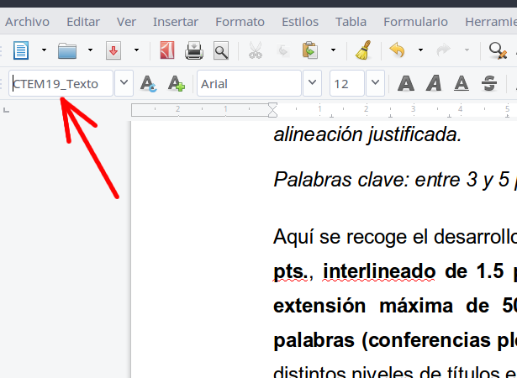

Image 2. Location of default styles

References
- Pazos, M. (1998). Bibliografía de matemática recreativa. Uno: Revista de didáctica de las matemáticas, nº. 18, pp. 73-94.
- Rodríguez, J. y García, P. (2018). Las matemáticas del arte. Más allá del número de oro. Colección Miradas Matemáticas. Editorial Catarata.
- Salgado, M. (2011-2018). Eu cociño, ti cociñas? Recuperado de http://eucocinoticocinas.blogspot.com/

References must be ordered alphabetically and contain all the necessary information to be located. To quote them in the text, it will be enough to indicate its number [1].

