LOVE ME DO
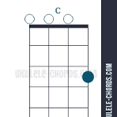
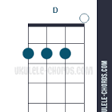
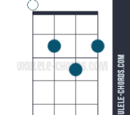
G C
Love, love me do
G C ACORDS
You know I love you
G C
I'll always be true
C G RITME CALIPSO

So pleeeeeease... Love me do
C G
Woah love me do

G C
Love, love me do
G C THE BEATLES
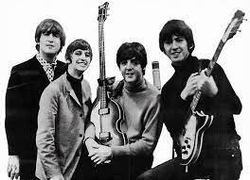
You know I love you
G C
I'll always be true
C G
So pleeeeeease... Love me do
C G
Woah love me do

[Bridge]
D C G
Someone to love, somebody new
D C G
Someone to love, someone like you

[Verse 3]
G C
Love, love me do
G C
You know I love you
G C
I'll always be true
C G
So pleeeeeease... Love me do
C G
Woah love me do

C G
Woah love me do
C G
Woah love me do
C G
Woah love me do

D G C G

