wear |  | dur (roba) | write |  | escriure
find |  | trobar | win |  | guanyar
go | 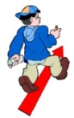 | anar | buy | 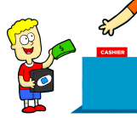 | comprar
have |  | tindre | meet |  | conèixer
see | 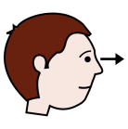 | veure | say | 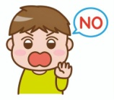 | dir
drink |  | beure | eat | 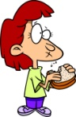 | menjar
drive | 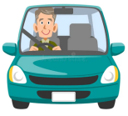 | conduir | travel | 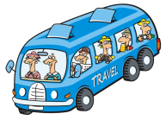 | viatjar
work |  | treballar | want |  | voler
look | 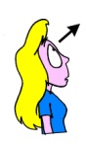 | mirar | listen |  | escoltar
watch | 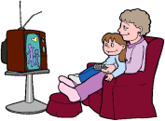 | veure (tv) | open |  | obrir
collect | 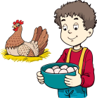 | arreplegar | visit | 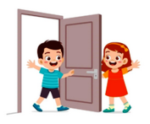 | visitar

PAST SIMPLE (passat simple)
FORMA AFIRMATIVA | Irregulars: estudiar llista
 | Regulars: passat i participi → -ed (recordeu les 3 regles)
FORMA NEGATIVA | Posem didn’t davant del verb i el verb normal, sense passat
PREGUNTA | Posem Did al principi de la pregunta i el verb normal, sense passat (*)
 | (*) Si fa falta partícula interrogativa (question word), anirà davant del tot

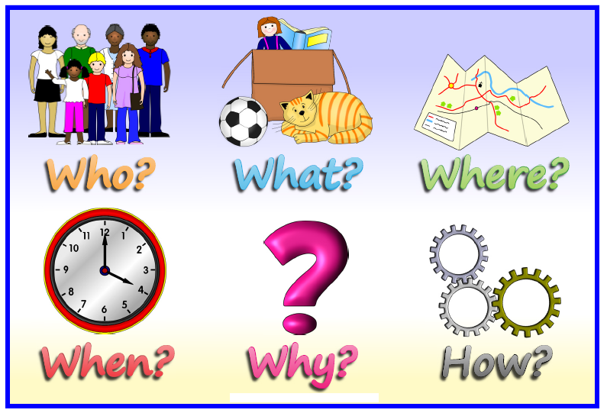
Com?
Per què?
Quan?
On?
Qui?
Què?
Si acaba en –y → se cambia por i +ed (si y es vocal)
→ + ed ( si y es consonante)
Study → studied Play → played
Si acaba en –e → se quita la -e +ed
Decide →decided
Si tiene una sola vocal y una sola consonante final → se repite la consonante +ed

Stop → stopped
OJO: Travel → travelled
Prefer → preferred
REGLES

VERB |  | INFINITIVE |  |  | PAST SIMPLE |  |  | PAST PARTICIPLE
ser/estar |  | be | /bi:/ |  | was / were | /wɒs//wɜ:(r)/ |  | been | /bi:n/
empezar |  | begin | /bɪˈgɪn/ |  | began | /bɪˈgæn/ |  | begun | /bɪˈgʌn/
morder |  | bite | /baɪt/ |  | bit | /bɪt/ |  | bitten | /ˈbɪtn/
soplar |  | blow | /bləʊ/ |  | blew | /blu:/ |  | blown | /bləʊn/
romper |  | break | /breɪk/ |  | broke | /brəʊk/ |  | broken | /brəʊkn/
traer |  | bring | /brɪŋ/ |  | brought | /brɔ:t/ |  | brought | /brɔ:t/
construir |  | build | /bɪld/ |  | built | /bɪlt/ |  | built | /bɪlt/
comprar |  | buy | /baɪ/ |  | bought | /bɔ:t/ |  | bought | /bɔ:t/
atrapar |  | catch | /kætʃ/ |  | caught | /kɔ:t/ |  | caught | /kɔ:t/
elegir |  | choose | /ʧu:z/ |  | chose | /ʧəʊz/ |  | chosen | /ˈʧəʊzn/
venir |  | come | /kʌm/ |  | came | /keɪm/ |  | come | /kʌm/
costar |  | cost | /kɒst/ |  | cost | /kɒst/ |  | cost | /kɒst/
cortar |  | cut | /kʌt/ |  | cut | /kʌt/ |  | cut | /kʌt/
hacer |  | do | /du:/ |  | did | /dɪd/ |  | done | /dʌn/
dibujar |  | draw | /drɔ:/ |  | drew | /dru:/ |  | drawn | /drɔ:n/
soñar |  | dream | /dri:m/ |  | dreamt | /dremt/ |  | dreamt | /dremt/
beber |  | drink | /drɪŋk/ |  | drank | /dræŋk/ |  | drunk | /drʌŋk/
conducir |  | drive | /draɪv/ |  | drove | /drəʊv/ |  | driven | /ˈdrɪvn/
comer |  | eat | /i:t/ |  | ate | /eɪt/ |  | eaten | /ˈi:tn/
caer |  | fall | /fɔ:l/ |  | fell | /fel/ |  | fallen | /ˈfɔ:ln/
sentir |  | feel | /fi:l/ |  | felt | /felt/ |  | felt | /felt/
luchar |  | fight | /faɪt/ |  | fought | /fɔ:t/ |  | fought | /fɔ:t/
encontrar |  | find | /faɪnd/ |  | found | /faʊnd/ |  | found | /faʊnd/
volar |  | fly | /flaɪ/ |  | flew | /flu:/ |  | flown | /fləʊn/
olvidar |  | forget | /fəˈget/ |  | forgot | /fəˈgɒt/ |  | forgotten | /fəˈgɒtn/
congelar |  | freeze | /fri:z/ |  | froze | /frəʊz/ |  | frozen | /ˈfrəʊzn/
obtener |  | get | /get/ |  | got | /gɒt/ |  | got | /gɒt/
dar |  | give | /gɪv/ |  | gave | /geɪv/ |  | given | /ˈgɪvn/
ir |  | go | /gəʊ/ |  | went | /went/ |  | gone | /gɒn/
crecer |  | grow | /grəʊ/ |  | grew | /gru:/ |  | grown | /ˈgrəʊn/
colgar |  | hang | /hæŋ/ |  | hung | /hʌŋ/ |  | hung | /hʌŋ/
tener |  | have | /hæv/ |  | had | /hæd/ |  | had | /hæd/
oír |  | hear | /hɪə(r)/ |  | heard | /hɜ:d/ |  | heard | /hɜ:d/
esconder |  | hide | /haɪd/ |  | hid | /hɪd/ |  | hidden | /ˈhɪdn/
golpear |  | hit | /hɪt/ |  | hit | /hɪt/ |  | hit | /hɪt/
sujetar |  | hold | /həʊld/ |  | held | /held/ |  | held | /held/
doler |  | hurt | /hɜ:t/ |  | hurt | /hɜ:t/ |  | hurt | /hɜ:t/
saber |  | know | /nəʊ/ |  | knew | /nju:/ |  | known | /nəʊn/
aprender |  | learn | /lɜ:n/ |  | learnt | /lɜ:nt/ |  | learnt | /lɜ:nt/
salir |  | leave | /li:v/ |  | left | /left/ |  | left | /letf/
prestar |  | lend | /lend/ |  | lent | /lent/ |  | lent | /lent/
permitir |  | let | /let/ |  | let | /let/ |  | let | /let/
tumbarse |  | lie | /laɪ/ |  | lay | /leɪ/ |  | lain | /leɪn/
encender |  | light | /laɪt/ |  | lit | /lɪt/ |  | lit | /lɪt/
perder |  | lose | /lu:z/ |  | lost | /lɒst/ |  | lost | /lɒst/
hacer |  | make | /meɪk/ |  | made | /meɪd/ |  | made | /meɪd/
significar |  | mean | /mi:n/ |  | meant | /ment/ |  | meant | /ment/
encontrarse |  | meet | /mi:t/ |  | met | /met/ |  | met | /met/
pagar |  | pay | /peɪ/ |  | paid | /peɪd/ |  | paid | /peɪd/
poner |  | put | /pʊt/ |  | put | /pʊt/ |  | put | /pʊt/
leer |  | read | /ri:d/ |  | read | /red/ |  | read | /red/
montar |  | ride | /raɪd/ |  | rode | /rəʊd/ |  | ridden | /ˈrɪdn/
sonar |  | ring | /rɪŋ/ |  | rang | /ræŋ/ |  | rung | /rʌŋ/
elevar |  | rise | /raɪz/ |  | rose | /rəʊz/ |  | risen | /ˈrɪzn/
correr |  | run | /rʌn/ |  | ran | /ræn/ |  | run | /rʌn/
decir |  | say | /seɪ/ |  | said | /sed/ |  | said | /sed/
ver |  | see | /si:/ |  | saw | /sɔ:/ |  | seen | /si:n/
vender |  | sell | /sel/ |  | sold | /səʊld/ |  | sold | /səʊld/
enviar |  | send | /send/ |  | sent | /sent/ |  | sent | /sent/
colocar |  | set | /set/ |  | set | /set/ |  | set | /set/
brillar |  | shine | /ʃaɪn/ |  | shone | /ʃɔ:n/ |  | shone | /ʃɔ:n/
disparar |  | shoot | /ʃu:t/ |  | shot | /ʃɒt/ |  | shot | /ʃɒt/
mostrar |  | show | /ʃəʊ/ |  | showed | /ʃəʊd/ |  | shown | /ʃəʊn/
cerrar |  | shut | /ʃʌt/ |  | shut | /ʃʌt/ |  | shut | /ʃʌt/
cantar |  | sing | /sɪŋ/ |  | sang | /sæŋ/ |  | sung | /sʌŋ/
sentarse |  | sit | /sɪt/ |  | sat | /sæt/ |  | sat | /sæt/
dormir |  | sleep | /sli:p/ |  | slept | /slept/ |  | slept | /slept/
hablar |  | speak | /spi:k/ |  | spoke | /spəʊk/ |  | spoken | /ˈspəʊkn/
gastar |  | spend | /spend/ |  | spent | /spent/ |  | spent | /spent/
estar en pie |  | stand | /stænd/ |  | stood | /stʊd/ |  | stood | /stʊd/
robar |  | steal | /sti:l/ |  | stole | /stəʊl/ |  | stolen | /ˈstəʊln/
golpear |  | strike | /straɪk/ |  | struck | /strʌk/ |  | struck | /strʌk/
nadar |  | swim | /swɪm/ |  | swam | /swæm/ |  | swum | /swʌm/
coger |  | take | /teɪk/ |  | took | /tʊk/ |  | taken | /ˈteɪkn/
enseñar |  | teach | /ti:ʧ/ |  | taught | /tɔ:t/ |  | taught | /tɔ:t/
decir |  | tell | /tel/ |  | told | /təʊld/ |  | told | /təʊld/
pensar |  | think | /θɪnk/ |  | thought | /θɔ:t/ |  | thought | /θɔ:t/
lanzar |  | throw | /θrəʊ/ |  | threw | /θru:/ |  | thrown | /θrəʊn/
entender |  | understand | /ˌʌndəˈstænd/ |  | understood | /ˌʌndəˈstʊd/ |  | unsderstood | /ˌʌndəˈstʊd/
despertar |  | wake | /weɪk/ |  | woke | /wəʊk/ |  | waked | /ˈweɪkt/
usar |  | wear | /weə(r)/ |  | wore | /wɔ:(r)/ |  | worn | /wɔ:n/
ganar |  | win | /wɪn/ |  | won | /wʌn/ |  | won | /wʌn/
escribir |  | write | /raɪt/ |  | wrote | /rəʊt/ |  | written | /ˈrɪtn/
*Sólo hay que estudiar los que están en blanco

