Stuffed Eggs

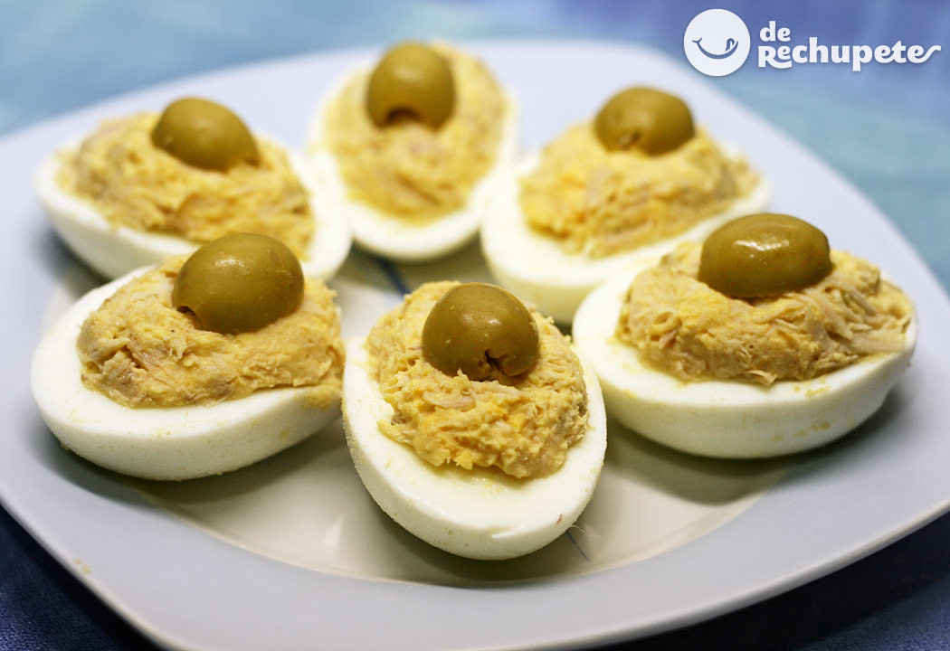
INGREDIENTS:
+Eggs
+Tuna
+Mayonnaise

METHOD:
1- Boil the eggs.
2- Take out the yolks.
3- Mix the tuna,the yolks and the mayonnaise in a bowl.
4- Take a spoonful of the mixture and put it inside the egg.
5- Put an olive on top.
6- Put them on a plate and serve.

