EUROPEAN SQUID WITH ARTICHOKE

THE INGREDIENTS:

- 200 grams of European squid
- 4 artichokes
- 1 onion
- 1garlic
- 200 ml oil
-salt
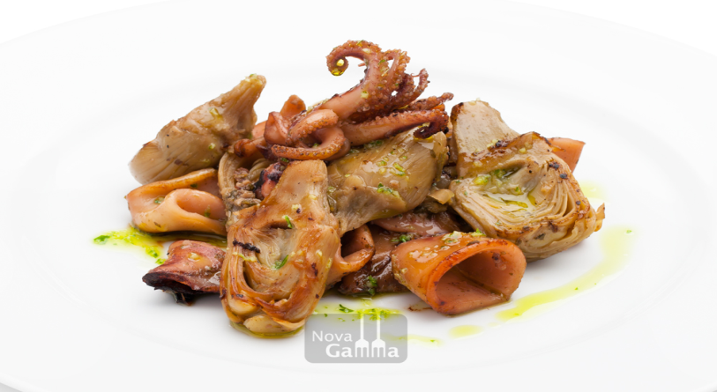

PREPARIATION:
1- Fry the artichoke with oil and salt for ten minutes.

2-Add the European Squid and fry everything for another ten minutes.

3- Put the onion and the garlic, then, cook for 15 minutes.

4- Put the European Squid with artichoke on a plate.

Lourdes Vea Lladser

