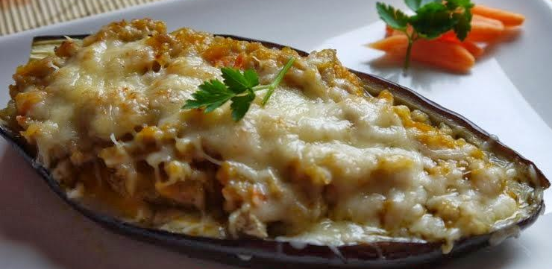
STUFFED AUBERGINE

Ingredients:
- Aubergine/s
- Onion
- Bacon
- Minced meat
- Grated cheese
- Garlic
How to make it:
- Break the aubergine in half and empty it.
- Fry the aubergine.
- Put the aubergine in the cooking pot.
- Chop the onion, the garlic, the bacon and the meat.
- Fry the minced meat, the onion, the garlic, and the meat of the aubergine.
- Put it in the aubergine.
- Put the grated cheese on top of the aubergine.
- Put the aubergine in the oven (250º-240º for 10 minutes).

