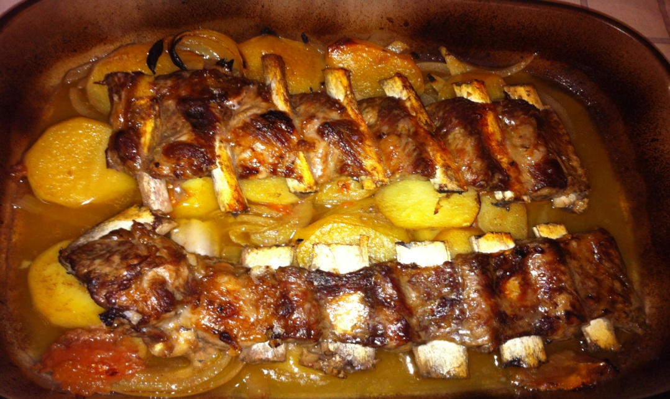
RIBS WITH POTATOES

Ingredients:

- pork ribs
- chicken
- potatoes
- a clove of garlic
- half onion
- olive oil
- salt and pepper
- laurel

Utensils:
- knife
- spatula
- baking sheet

Method:
- Preheat the oven to 180º.
- Put the ribs, the chicken, the clove of garlic and the laurel on the baking sheet.
- Peel the potatoes and cut the onion.
- After that, put the ribs, the chicken, the clove of garlic and the laurel in the oven for 30 minutes. And later, add the potatoes and the onion in the oven for 60 minutes. And finally get it out of the oven and put it on the plates.

- Mmmm... This stew is delicious.

