A RECIPE OF MY FAVOURITE MEAL

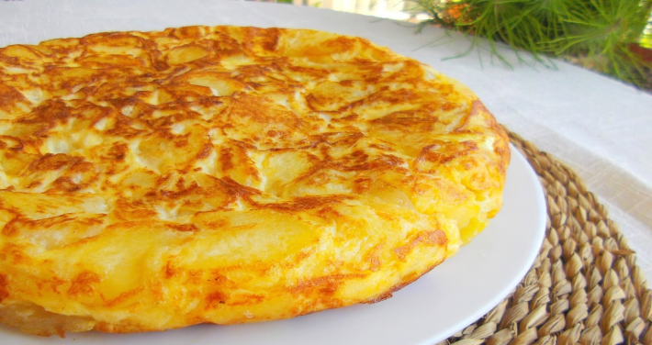
INGREDIENTS:

- 4/6 EGGS
- 1 ONION,PREFERABLY WHITE
- 4 POTATOES
- 150 ML OLIVE OIL
- SALT

METHOD:

- Peel the potatoes, cut them into slices and chop the onion.
- Heat the oil in a big frying pan, add the potatoes and onion and fry them gradually, partially covered, for 30 minutes. Strain the potatoes and onions with a colander into a bowl.
- Beat the eggs separately, then pour them into the potatoes and add some salt. Heat a little of the strained oil in a pan. Pour everything into the pan and cook on a moderate heat, using a spatula.
- When it is ready, invert on a plate and put it back into the pan and cook a few more.
- Cool for 10 minutes, serve it on a plate and enjoy it!

