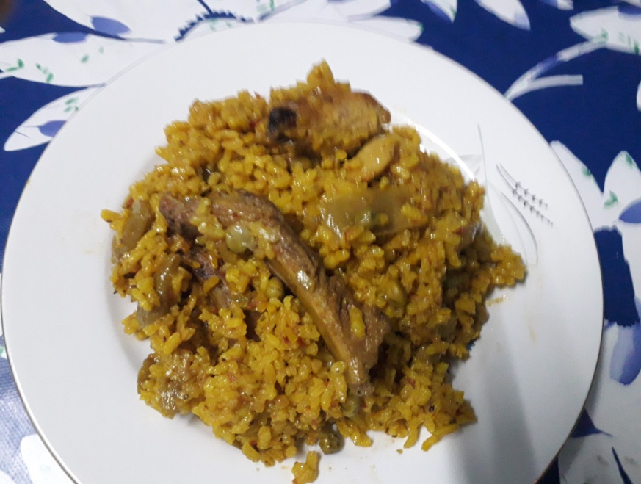
Recipe for Paella

Ingredients:
- Rice
- Chicken Meat
- Pork ribs
- Rabbit meat
- Garlic
- Red pepper
- Tomato
- Green peas
- Green Beans
- Oil
- Saffron
- Salt

Method:
- Put some oil in a big frying pan.
- Salt the meat and fry it.
- Cut the red pepper and green beans into small pieces.
- When the meat is fried, add the red pepper and green beans and fry them with the meat.
- Chop the garlic and fry it with the meat.
- Put the crushed tomato into the frying pan, and fry it together with the meat and vegetables.
- Pour water into the frying pan and let it boil for 30 minutes.
- Add the rice.
- Season it with salt and put saffron.
- Cook it for 20 minutes.

